**Combining facilitation theory with radiotelemetry to assess the benefits of desert shrubs to an endangered lizard**

**Abstract**

Shrubs are known to play a key role in the structure of desert communities and can function as foundation species. Foundation species provide crucial benefits to other species and can enhance the resilience of the community. Describing the relationships among shrubs and other species, including vertebrates, is important for preserving and restoring desert habitat. Prior efforts based on movement ecology to characterize the importance of a foundation species shrub, *Ephedra californica*, to the endangered blunt-nosed leopard lizard, *Gambelia sila*, obtained ambiguous results. We approached the same question from the perspective of ecological facilitation, which has been well developed in the context of analyzing the interactions of shrubs with other species. We sought to directly test the association between lizards and shrubs by taking locality data from radiotagged lizards at multiple times throughout the lizard’s daily movements, each time assessing whether a particular lizard was associated either with a shrub or one of several alternative habitats**.** We also recorded behavioral observations to ask whether particular behaviors were correlated with lizard use of shrubs. We obtained strong evidence for shrub use by *G., sila* and found shrub use to be correlated with time of day, thermoregulatory behavior and predator avoidance. Our study suggests that shrubs be considered as a component of high-quality habitat for *G. sila* when making decisions about habitat preservation or restoration and provides a model for assessing similar relationships for other desert species at risk.

**Introduction**

The conversion and loss of desert habitat is a global biodiversity crisis requiring immediate intervention, including conservation of remaining undisturbed habitat and restoration of degraded desert (). (Hannah et al. 1995, Hoekstra et al. 2005, Kefi et al. 2007). (Hoekstra et al. 2005). (Mouat et al. 2008, Bachelet et al. 2016, Westphal et al. 2016). Identifying the drivers of ecological health in desert communities will be a crucial component of such interventions (). Shrubs are known to play important roles in the maintenance of diverse desert plant communities (Flores & Jurado 2003). Ecological facilitation theory, which seeks to identify benefits of one organisms to another, has been a key model for describing and predicting the interaction of shrubs with other organisms within their communities (). Using facilitation theory Filazzola et al (2017) extended the exploration of the beneficial interactions of desert shrubs to vertebrates, but their measures of association (feces detection, trap cameras) were correlative and ambiguous with respect to the proximate drivers of the shrub x lizard interaction. Radiotelemetry allows the longitudinal tracking of individual animals throughout their daily behavioral cycles and promotes the field observation of key behaviors. We therefore initiated a radiotelemetry study to test and refine our understanding of the interaction of shrub with lizard.

We developed our study within the same system used by Filazzola et al (2017): the co-occurrence of California jointfir *Ephedra californica* with the blunt-nosed leopard lizard *Gambelia sila*. Both species are important ecological and conservation components of the San Joaquin Desert (Germano et al. 2011). The San Joaquin Desert supports one of the highest concentrations of threatened and endangered species in the continental United States, including species such as the San Joaquin kit fox (*Vulpes macrotis mutica*) andgiant kangaroo rat (*Dipodomys ingens*), (USFWS 1998, Germano et al 2011). Much of this area has been converted to agriculture or developed for industry such as oil extraction and solar energy, with natural desert habitat only covering 5% of its former extent (Germano et al 1992, USFWS 1998, Germano et al 2011). What natural habitat remains is fragmented, with only a few large patches still intact, such as the Carrizo Plain, Panoche Valley, and Pixley National Wildlife Refuge (USFWS 1998, Germano et al 2011).

In this study, we examined the relationship between blunt-nosed leopard lizard and shrubs in Carrizo Plain National Monument, the largest remaining remnant of San Joaquin Desert habitat. We used radio telemetry to track the daily movements of individual lizards. We recorded the association of lizards with shrubs via geographic proximity at two scales, one coarse (‘shrub’ vs. ‘open’) and a finer-grained description nested within the coarse scale (at burrow, on open ground, etc.) We also included a brief behavioral observation from a list of predefined behaviors in each instance. Our rationale for including behavioral data was that they might provide insights into the proximate drivers of any shrub x lizard association we observed. We calculated the home ranges of individual lizards for the purposes of comparing our study with previous radiotelemtry studies of *G. sila* and to assess the availability of shrub habitat to each lizard as well as any interactions of home range size with shrub use.

**Methods**

*Study site***.--** We conducted our telemetry study on the Elkhorn Plain within Carrizo Plain National Monument (San Luis Obispo County, California, USA, 35.1914° N, 119.7929° W). Average annual precipitation within the monument ranges from 15 cm in the southeast to 25 cm in the northwest (Hijmans et al. 2005). The Elkhorn Plain is located within the Monument on an elevated plain separated from the main valley floor of the Carrizo Plain by the San Andreas Fault (Germano et al. 1994). The area has been heavily invaded by non-native annual grasses including *Bromus madritensis, Erodium cicutarium*, and *Hordeum murinum* (Schiffman 1994, Gurney et al. 2015). The dominant shrubs on the Elkhorn Plain are California jointfir (*Ephedra californica*) and saltbrush (*Atriplex polycarpa*) (Stout et al. 2013). *Ephedra* was the sole dominant shrub at our study site with only a few saltbrush found in adjacent areas. *G. sila* had been found in the area during surveys by our research team in previous years as well as being documented by historical studies (German et al. 2007).

*Study species* .-- The blunt-nosed leopard lizard is a state and federally listed endangered species found in the San Joaquin Desert of California (Germano et al. 1992, USFWS 1998, Warrick et al. 1998, Germano et al. 2016). *G. sila* is relatively large lizard compared to other temperate New World lizards, with males ranging from 89 to 119 mm and females ranging from 86 to 112 mm (Tollestrup 1982, Warrick et al. 1998, Germano et al. 2016). They are diurnal and mainly insectivorous though they may eat smaller lizard species such as side blotched lizards (*Uta stansburiana elegans*) on occasion (Warrick et al. 1998, Germano et al. 2007, Germano et al. 2016). Blunt-nosed leopard lizards are also prey for many species including snakes, bird of prey and coyotes (Germano et al. 1992, USFWS 1998, Germano et al. 2005). Though leopard lizards can bury themselves and will occasionally dig primitive burrows, they mostly utilize abandoned burrows of other animals as kangaroo rats (Fields et al. 1994, Grillet et al. 2010, Prugh et al. 2011). Adult blunt-nosed leopard lizards are inactive in burrows for much of the year, emerging only from late March or April through July (USFWS 1998, Warrick et al. 1998, Germano et al. 2016). During the active season lizards will also spend the night underground in burrows and may return to a burrow during the day if the temperature becomes too hot or cold (Warrick et al. 1998, Germano et al. 2016).

*Experimental design*.-- Lizards were located during foot and vehicle surveys and captured using a pole and noose made of either dental floss or surgical thread. The sex of each lizard was determined, and its snout to vent length (SVL) and mass were measured. Lizards were collared following the method of Germano et al. (2016). VHF radio transmitters (Holohil model BD-2, frequency 151-152 MHz, battery life 8-16 weeks, Holohil Systems Ltd., Carp, ON, Canada) were attached to a small beaded chain collar using jewelry wire and epoxy, and the collars were then fastened around the lizard’s neck. Lizards were kept overnight to ensure the collar was fitted correctly and did not irritate or harm the animal, and then were then released at their capture site. Collars weighed 1.6-2.2 grams (depending on the size of chain needed for the lizard’s neck), and we ensured that the weight of the collar did not exceed between 5% and 10% of the body mass of the individual.

In the first two days following release all lizards were relocated (i.e. repeatedly sighted using telemetry) several times between to ensure that the lizards were successfully adjusting to the collars and that impacts to their behavior and survival were minimal. We looked for any negative effects the collar had on the lizards, such as impacts on movement, parts of the collar catching on plants or causing abrasions on the lizard, and any deviation from normal lizard behaviors. The lizards were then formally surveyed for 15 consecutive days. Surveys were conducted on each lizard 3 times a day. Two of these daily surveys were conducted during daylight hours, when lizards were typically active above ground. One survey was conducted before noon and one was conducted after noon. The third survey was conducted during the night when lizards are inactive below ground. The ‘night survey’ was conducted before 7:30 AM or after 7:30 PM on each day.

Lizards were located using a 3-element Yagi antenna and Model R-100 telemetry receiver (Communications Specialists, Inc., Orange, CA, USA). Once found, a location was taken for each lizard using a Garmin 64st GPS unit (Garmin Ltd., Olathe, KS, USA) and a laser range-finder (Bushnell Outdoor Products, Overland Park, KS, USA). Additionally, date and time, meso- and microhabitat, and behavior were recorded for each observation of a lizard. Mesohabitat was categorized as whether a lizard was within 0.5 meters of a shrub (shrub) or not (open). Microhabitat was recorded as the habitat where the lizard was observed at a finer spatial scale: (burrow, annuals, road, in shrub, bare patch, or wash). A brief behavior observation was taken for one minute at the same time (see supporting information Appendix A for behavior classifications). Behavior observations were brief to ensure that there would be adequate time to observe all animals 3 times daily. Disturbance from the observer to the lizard was kept to a minimum for each observation to avoid influencing behavior and habitat selection. At the completion of the study all collars were removed from the lizards.

*Analyses*.-- All analyses were conducted in R (version 3.3.2). Meso- and microhabitat were analyzed using a generalized linear model (Bolker et al. 2009) with the multcomp package (Hothorn et al. 2008). Behavioral data were analyzed with a multinomial logistic regression using the nnet package which accounts for the multiple levels of nominal outcomes of the observations (Venables et al. 2002). All locations of collared individuals were mapped using the leaflet package (Graul 2016). Home range size was calculated using a 95% Minimum Convex Polygon (MCP) estimation (Mohr 1947) using the adehabitatHR package (Calenge 2006). MCPs were visualized in two dimensions in R and with Zoatrack ( )All R code used for this project can be found at <https://cjlortie.github.io/Carrizo.telemetry. Shrub density was calculated by visually counting individual shrubs from aerial photographs within each lizard’s MCP and dividing that number by the area in square meters of the MCP.

**Results**

The study took place in July 2016. A total of 31 lizards was tracked, comprising 14 females, 15 males, and 2 juvenile lizards of whose sex could not be determined. Home range sizes were calculated for 29 of the lizards. Of the 3 lizards where home range was not calculated, two were found dead in the first few days of the study and the third was lost due to silent signal. Mean home range size was 10790 m2 and ranged from 0.5 m2 (this was an individual that had gone dormant for the summer and did not move or emerge from its burrow during the study) to 38600 m2. The total area occupied by the sum of all home ranges was 1.7145 km2. As we sampled during only a portion of the time that lizards are active during the year (15 days), this is likely an underestimate of home range sizes for this species **.**

The frequency of lizard observation differed significantly between mesohabitat types (Table 1, p < 0.01). Lizards were observed more frequently at open mesohabitat (73.7 % of observations) than at shrub mesohabitat (26.3%). Frequency of observation between different times of day was also significantly different for mesohabitat (Table 1, p < 0.01). Observations of lizards at open mesohabitat did not differ between different times of day, however, observations at shrub mesohabitat did differ significantly between morning and afternoon. Lizards were found more frequently at shrubs in the afternoon than in the morning (Table 1, p = 0.0252). Fine-scale observation patterns at the microhabitat scale were similar to the patterns at the mesohabitat scale. The frequency of observations differed significantly between microhabitat types (Table 2, p < 0.0001), with lizards found at burrow microhabitat significantly more than any other type (58.4% of observations, Table 2, p < 0.0001). The frequency of observations at shrub microhabitat was also significantly greater than any other microhabitat types besides burrows (15.9% of observations, Table 2, p < 0.0001). Lizards were observed at shrub microhabitat more frequently than in annuals, bare patches, washes, and roads. Observation frequency also differed significantly between different times for microhabitat (Table 2, p < 0.0001). Lizard observations at shrub microhabitat differed between morning and afternoon, with more shrub observations occurring in the afternoon (Table S2, p = 0.0003). Night refugia accounted for about 12% of the total number of observations of lizards at shrubs.

Behavior observations differed significantly between habitat types (Table 3, p < 0.0001). Lizards were observed cooling or thermoregulating under shrubs significantly more than other habitat types (Table 3, p <0.0001). Lizards were also observed avoiding predators under shrubs more frequently than other habitat types (Table 3, p < 0.0001). The predators lizards were observed avoiding in this study were all aerial predators (either ravens or raptor species). Other types of behavior such as running, hunting, or active observation by lizards did not differ significantly between habitat types. Observed behavior also differed significantly between different times of day with some behaviors being observed more frequently at certain times of day (Table 3, p < 0.001) e.g. lizards were more frequently observed sunning in the morning in both mesohabitat types compared to the afternoon (Table 3, p < 0.001).

**Discussion**

Shrubs are known to be a foundation species in many ecosystems because of the facilitative benefits, such as shelter, refuge, and food resources, they provide to both plant and animal species **(**Filazzola et al. 2014, Lortie et al. 2015). The timing of increased observations at shrubs in the afternoon and the types of behaviors that were observed significantly more at shrubs suggest that shrubs facilitate lizards. Our behavioral observations suggest that lizards seek out the shade that shrubs provide during the hottest part of the day, supporting the role of shrubs as a site for thermoregulation (Kerr et al. 2004, Pugnaire 2010). Shrubs are well documented as a source of refuge for many prey animals including lizards (Anderson et al. 2010, Filazzola et al. 2017). Predator avoidance behaviors were more frequently observed under shrubs. Observations of behaviors were not significantly different between habitat types. This may be due to the opportunistic nature of leopard lizard hunting behavior. Lizards will hunt prey when and where it is present, rather than seeking out a specific habitat for hunting (Pietruszka et al. 1981, Germano et al. 2007). We saw interactions of *E. californica* and *G. sila* that were mediated by thermoregulatory and predator-avoidance behaviors, but shrubs likely provide other benefits to lizards through indirect interactions due to the shrub’s positive effect on many other species such as burrowing mammals (Hansen et al. 1994, Fields et al. 1999, Prugh et al. 2011, Filazzola et al. 2017).

Scale is important in ecology because relevant processes can function at many scales simultaneously, and patterns can vary in magnitude and sign at local versus landscape levels (Schneider 2001, Chave 2013). We did not sample on a continuum that varied to this extent but did examine mesohabitat versus microhabitat scales relevant to a desert lizard. We found close correspondence between the two scales tested with, lizards being found most frequently at a certain habitat types.

Direct facilitation by shrubs was also detected at both scales because shrubs were used significantly more than all remaining mesohabitat and microhabitat categories except burrows. Shrubs buffer the extremes of environmental conditions such as temperature, wind, and solar radiation, creating a moderate microclimate under their canopy (Kerr et al. 2004, Pugnaire 2010). Shelter against temperature changes is particularly important for poikilotherms such as reptiles, which must maintain body temperature through behavior (Huey 1974, Díaz and Cabezas-Díaz 2004, Kerr et al. 2004). Visual concealment from predators and physical protection, is also important (Fields et al. 1999, Anderson et al. 2010, Filazzola et al. 2017). Overall, lizards were located over 75% of their time near a shrub or burrow. These patterns suggest the importance to lizards of having some form of shelter and/or refuge within close proximity (Huey 1974, Díaz and Cabezas-Díaz 2004, Anderson et al. 2010). The advantage of having a quick escape from predators and easy access to shade may cause lizards to concentrate in areas where cover is available, whether this is in the form of burrows alone or in combination with shrubs as with this study site.

In summary, our findings suggest that shrubs are foundation species for animals in deserts both because of direct benefits they provide, as well as the influence shrubs have may on the microhabitat through their effects on burrowing mammals (Filazzola et al. 2014, Lortie et al. 2015).

**Management Implications**

*G. sila*’s close association with shrubs when present indicates that positive interactions between shrub and lizards can be beneficial to lizards (Warrick et al. 1998, Lortie et al. 2015, Filazzola et al. 2017). Lizards used shrubs significantly more for behaviors such as thermoregulation and predator avoidance over other habitat types. Body temperature regulation is of particular importance to the survival of poikilotherms such as lizards (Huey 1974, Díaz and Cabezas-Díaz 2004, Kerr et al. 2004). With climate change predicted to have a high impact on this area, this activity could potentially take up even more time due to increased temperature stress on lizards (Vickers 2011, Westphal et al. 2016, Filazzola et al. 2017). The presence of shrubs, whether naturally occurring or planted, could benefit lizards by providing additional sources of shelter and refuge (Kerr et al. 2004, Lortie et al. 2015, Filazzola et al. 2017). Shrubs can also benefit other burrow-dwelling species, such as kangaroo rats (Hawbecker 1951, Prugh et al. 2011, Lortie et al. 2015). Higher densities of burrows are found under shrubs compared to open areas (Hansen et al. 1994, Filazzola et al. 2017). Burrows are often used by lizards for shelter and refuge (Hansen et al. 1994, Grillet et al. 2010), so the increased abundance of these burrowing animals could increase burrow density (Prugh et al. 2011). This would provide additional benefits to lizards due to the increased shelter and refuge available (Steffen et al. 2006, Filazzola et al. 2017). Shrubs therefore should be taken into account as part of the effort to recover *G. sila*. These findings are likely applicable to other lizard species and small animals that face similar environmental conditions. By including shrubs as an aspect of the blunt-nosed leopard lizard recovery plan, land managers can help to ensure quality habitat is available for leopard lizards and ensure their survival into the future.

**References**

Anderson R.A., Housman M.L., Grant L.J. 2010. The role of running in predation and antipredation by the leopard lizard, *Gambelia wislizenii*. SICB 2010 Annual Meeting.

Bachelet D., Ferschweiler K., Sheehan T., Strittholt J. 2016. Climate change effects on southern California deserts. Journal of Arid Environments. 127: 17-29.

Bolker, B. M., Brooks, M. E., Clark, C. J., Geange, S. W., Poulsen, J. R., Stevens, M. H. H. and White, J.-S. S. 2009. Generalized linear mixed models: a practical guide for ecology and evolution. - Trends in Ecology & Evolution 24: 127-135.

Bruno, J. F., Stachowicz, J. J. and Bertness, M. D. 2003. Inclusion of facilitation into ecological theory. Trends in Ecology and Evolution 18: 119-125.

Bulleri, F., Bruno, J. F., Silliman, B. R. and Stachowicz, J. J. 2016. Facilitation and the niche: implications for coexistence, range shifts and ecosystem functioning. - Functional Ecology 30: 70-78.

Chave J. 2013. The problem of pattern and scale in ecology: what have we learned in 20 years? Ecology Letters. doi: 10.1111/ele.12048

Crowley S. R., Pietruszka, R. D. 1983. Aggressiveness and vocalization in the leopard lizard (*Gambelia wislizennii*): the influence of temperature. Animal Behaviour, 31(4), 1055-1060.

Cook E.R., Woodhouse C.A., Eakin C.M., Meko D.M., Stahle D.W. 2004.Long term aridity changes in the western United States. Science. 306: 1015–1018.

Díaz J.A., Cabezas-Díaz S. 2004. Seasonal variation in the contribution of different behavioural mechanisms to lizard thermoregulation. Functional Ecology. 18:867–875.

Fields M.J., Coffin D.P., Gosz J.R. 1999.Burrowing activities of kangaroo rats and patterns in plant species dominance at a shortgrass steppe-desert grassland ecotone. Journal of Vegetation Science. 10:123–130.

Filazzola A., Lortie C.J. 2014. A systematic review and conceptual framework for the mechanistic pathways of nurse plants. Global Ecology and Biogeography. 23: 1335-1345.

Filazzola A., Westphal M., Powers M., Liczner A.R., Woollett D.A.S., Johnson B., Lortie C.J. 2017. Non-trophic interaction in deserts: facilitation, interference and an endangered lizard species. Basic and Applied Ecology. http://dx.doi.org/10.1016/j.baae.2017.01.002.

Germano D.J., Williams D.F. 1992. Recovery of the blunt-nosed leopard lizard: past efforts, present knowledge, and future opportunities. Transactions of the Western Section of the Wildlife Society. 28:38-47.

Germano D.J., Williams D.F., Tordoff III W. 1994 Effect of drought on blunt-nosed leopard lizards (*Gambelia sila*). Northwestern Naturalist.75:11-19.

Germano D.J., Rathburn G.B., Saslaw L.R. 2001. Managing exotic grasses and conserving declining species. Wildlife Society Bulletin. 29(2):551-559.

Germano D.J., Williams D.F. 2005. Population ecology of blunt-nosed leopard lizard in high elevation foothill habitat. Journal of Herpetology. 39(1):1-18.

Germano D.J., Smith P.T., Tabor S.P. 2007. Food habits of the blunt-nosed leopard lizard (*Gambelia sila*). The Southwestern Naturalist. 52(2):318-323.

Germano D.J., Williams D.F. 2007. Ontogenetic and seasonal changes in coloration of the blunt-nosed leopard lizard (*Gambelia sila*). The Southwestern Naturalist. 52(1):46-53.

Germano D.J., Rathbun G.B., Saslaw L.R., Cypher B.L., Cypher E.A., Vredenberg L. The San Joaquin Desert of California: Ecologically misunderstood and overlooked. Natural Areas Journal. 2011;31:138-147

Germano D.J., Rathburn G.B., Saslaw L.R. 2012. Effects of grazing and invasive grasses on desert vertebrates in California. The Journal of Wildlife Management. 76(4):670-682.

Germano D.J., Rathbun G.B. 2016. Home range and habitat use by blunt-nosed leopard lizards in the southern San Joaquin Desert of California. Journal of Herpetology. 50(3):429-434.

Graul C. 2016. leafletR: Interactive Web-Maps Based on the Leaflet JavaScript Library. R package version 0.4-0, http://cran.r-project.org/package=leafletR.

Griffin D., Anchukaitis K.J. 2014.How unusual is the 2012–2014 California drought? Geophysical Research Letters. 41: 9017–9023.

Grillet P., Cheylan M., Thirion J.M., Doré F., Bonnet X., Dauge C., Chollet M., Marchand M.A. 2010. Rabbit burrows or artificial refuges area critical habitat component for the threatened lizard, *Timon lepidus* (Sauria, Lacertidae). Biodiversity and Conservation. 19: 2039–2051.

Gurney C.M., Prugh L.R., Brashares J.S. 2015. Restoration of native plants is reduced by rodent-caused soil disturbance and seed removal. Rangeland Ecology and Management. 2015;68(4):359-366.

Hannah L., Carr J.L., Lankerani A. 1995. Human disturbance and natural habitat: a biome level analysis of a global data set. Biodiversity and Conservation. 4: 128-155.

Hansen R.W., Montanucci R.R., Switak K.H. 1994.Blunt-nosed leopard lizard. Life on the Edge. Volume1: Wildlife 1: pp.272–273.

Hawbecker A.C. 1951. Small mammal relationships in an Ephedra community. Journal of Mammalogy. 50–60.

Hijmans, R.J., Cameron S.E., Parra J.L., Jones P.G., Jarvis A. Very high resolution interpolated climate surfaces for global land areas. International Journal of Climatology. 2005. 25: 1965-1978.

Hoekstra J.M., Boucher T.M., Ricketts T.H., Roberts C. 2005. Confronting a biome crisis: global disparities of habitat loss and protection. Ecology Letters. 8: 23-29.

Hothorn T, Bretz F, Westfall P. 2008. Simultaneous Inference in General Parametric Models. Biometrical Journal 50(3), 346--363.

Huey R.B. 1974. Behavioral thermoregulation in lizards: Importance of associated costs. Science. 184:1001–1003.

Jacobson, F., Garrison, G., Penner, J., Gebin, J. Z., Eifler, M., & Eifler, D. 2016. Escape behaviour in the leopard lizard (*Gambelia wislizenii*): effects of starting distance and sex. Amphibia-Reptilia. 37(3), 320-324.

Kefi, S., Rietkerk, M., Alados, C. L., Pueyo, Y., Papanastasis, V. P., ElAich, A. and de Ruiter, P. C. 2007. Spatial vegetation patterns and imminent desertification in Mediterranean arid ecosystems. Nature 449: 213-217.

Kerr G.D., Bull C.M. 2004. Microhabitat use by the scincid lizard *Tiliqua rugosa*: Exploiting natural temperature gradients beneath plant canopies. Journal of Herpetology. 38: 536–545.

Lortie, C.J., Filazzola A., Sotomayor D. Functional assessment of animal interactions with shrub- facilitation complexes: a formal synthesis and conceptual framework. Functional Ecology. 2015. 30: 41-51.

Medica P.A., Turner F.B., Smith D.D. 1973. Hormonal induction of color changes in female leopard lizards, *Crotaphytus wislizenii*. Copeia. 1973(4):658-661.

McIntire, E. J. B. and Fajardo, A. 2014. Facilitation as a ubiquitous driver of biodiversity. - New Phytologist 201: 403-416.

Milne T., Bull C.M. 2000. Burrow choice by individuals of different sizes in the endangered pygmy blue tongue lizard *Tiliqua adelaidensis*. Biological Conservation. 95:295–301.

Mouat D.A., Lancaster J.M. 2008. Drylands in Crisis. Environmental Change and Human Security. 67-80.

Mohr, C. 1947. Table of equivalent populations of North American small mammals. American Midland Naturalist. 37: 223–249.

Pietruszka R.D., Wiens J.A., Pietruszka C.J. 1981. Leopard lizard predation on perognathus. Journal of Herpetology. 15(2):249-250.

Prugh L.R., Brashares J.S. 2011. Partitioning the effects of an ecosystem engineer: kangaroo rats control community structure via multiple pathways. Journal of Animal Ecology. 81(3):667-678.

Pugnaire F.I. (ed.) 2010. Positive Plant Interactions and Community Dynamics. CRC Press, Boca Raton, FL, USA.

Ruttan A., Filazzola A., Lortie C. J. 2016. Shrub-annual facilitation complexes mediate insect community structure in arid environments. - Journal of Arid Environments 134: 1-9.

Schiffman P.M. Promotion of exotic weed establishment by endangered giant kangaroo rats (*Dipodomys ingens*) in a California grassland. Biodiversity and Conservation. 1994;3:524-537.

Schneider D.C. 2001. The rise of the concept of scale in ecology: the concept of scale is evolving from verbal expression to quantitative expression. BioScience. 51: 545-555.

Spiegel O., Leu S.T., Sih A., Godfrey S.S., Bull C.M. 2015. When the going gets tough: behavioural type-dependent space use in the sleepy lizard changes as the season dries. Proceedings of the Royal Society B. 282:20151768.

Stebbins R.C., McGinnis S.M. 2012.Field guide to amphibians and reptiles of California (Revised Edition). Berkeley, California: University of California Press. 552p.

Steffen J.E., Anderson R.A. 2006. Abundance of the long-nosed leopard lizard (*Gambelia wislizenii*) is influenced by shrub diversity and cover in southeast Oregon. The American Midland Naturalist. 156(1):201-207.

Stout D., Buck-Diaz J., Taylor S., Evens J. Vegetation mapping and accuracy assessment report for Carrizo Plain National Monument. California Native Plants Society. 2014. Available: https://www.cnps.org/cnps/vegetation/pdf/carrizo-mapping_rpt2013.pdf. Accessed Jan. 21th, 2017.

Tollestrup K. 1982. Growth and reproduction in two closely related species of leopard lizard, *Gambelia silus* and *Gambelia wislizenii*. The American Midland Naturalist. 108(1):1-20.

U.S. Fish and Wildlife Service. Recovery plan for upland species of the San Joaquin Valley, California. Portland, OR. 1998; 1-319.

Venables W. N., Ripley B. D. 2002. Modern Applied Statistics with S. Fourth Edition. Springer, New York. ISBN 0-387-95457-0

Vickers M., Manicom C., Schwarzkopf L. 2011. Extending the cost-benefit model of thermoregulation: high-temperature environments. The American Naturalist. 177: 452–461.

Warrick G.D., Kato T.T., Rose B.R. 1998. Microhabitat use and home range characteristics of blunt-nosed leopard lizards. Journal of Herpetology. 32(2):183-191.

Westphal M.F., Stewart J.A.E., Tennant E.N., Butterfield H.S., Sinervo B. 2016 Contemporary drought and future effects of climate change on the endangered blunt-nosed leopard lizard, *Gambelia sila*. PLoS ONE. 11(5): e0154838. doi:10.1371/journal.pone.0154838.

**Tables**

**Table 1**: Generalized linear model for mesohabitat, with degrees of freedom, deviance, and p-values.

|  |  |  |  |  |  |
| --- | --- | --- | --- | --- | --- |
| Generalized linear model |  |  |  |  |  |
| Factor | Df | Deviance | P-value |  |  |
| mesohabitat | 1 | 88.33 | < 0.0001 |  |  |
| Time class | 1 | 2.901 | 0.1 |  |  |
| mesohabitat:time.class | 1 | 5.281 | 0.01 |  |  |
|  |  |  |  |  |  |
|  |  |  |  |  |  |
| Post Hoc, least squared means |  |  |  |  |  |
| contrast | estimate | SE | df | z.ratio | p.value |
| open,AM-shrub,AM | 0.769229 | 0.102934 | NA | 7.473 | <.0001 |
| open,AM-open,PM | -0.01848 | 0.067966 | NA | -0.272 | 0.993 |
| open,AM-shrub,PM | 0.44597 | 0.085189 | NA | 5.235 | <.0001 |
| shrub,AM-open,PM | -0.78771 | 0.102727 | NA | -7.668 | <.0001 |
| shrub,AM-shrub,PM | -0.32326 | 0.11485 | NA | -2.815 | 0.0252 |
| open,PM-shrub,PM | 0.464446 | 0.084938 | NA | 5.468 | <.0001 |

**Table 2**: Generalized linear model for microhabitat with degrees of freedom, deviance, and p-values. For the least square means post hoc for microhabitat:time class see Supporting information.

|  |  |  |  |  |  |
| --- | --- | --- | --- | --- | --- |
| Generalized Linear Mode |  |  |  |  |  |
| Factor | Df | Deviance | P-value |  |  |
| microhabitat | 5 | 1044.1 | < 0.0001 |  |  |
| time class | 1 | 0.5 | > 0.5 |  |  |
| microhabitat:time.class | 5 | 55.26 | < 0.0001 |  |  |
|  |  |  |  |  |  |
|  |  |  |  |  |  |
| Microhabitat Post Hoc, Least squared means |  |  |  |  |  |
| contrast | estimate | SE | df | z.ratio | p.value |
| annuals-bare | 0.3377215 | 0.179633 | NA | 1.88 | 0.4145 |
| annuals-burrow | -1.95300636 | 0.131068 | NA | -14.901 | <.0001 |
| annuals-road | 0.50298261 | 0.218936 | NA | 2.297 | 0.195 |
| annuals-shrub | -1.06739262 | 0.144933 | NA | -7.365 | <.0001 |
| annuals-wash | 0.24454864 | 0.166362 | NA | 1.47 | 0.6836 |
| bare-burrow | -2.29072786 | 0.134072 | NA | -17.086 | <.0001 |
| bare-road | 0.16526112 | 0.220747 | NA | 0.749 | 0.9757 |
| bare-shrub | -1.40511412 | 0.147655 | NA | -9.516 | <.0001 |
| bare-wash | -0.09317285 | 0.168739 | NA | -0.552 | 0.9939 |
| burrow-road | 2.45598898 | 0.183412 | NA | 13.391 | <.0001 |
| burrow-shrub | 0.88561374 | 0.081932 | NA | 10.809 | <.0001 |
| burrow-wash | 2.19755501 | 0.115688 | NA | 18.996 | <.0001 |
| road-shrub | -1.57037523 | 0.193563 | NA | -8.113 | <.0001 |
| road-wash | -0.25843397 | 0.210089 | NA | -1.23 | 0.8222 |
| shrub-wash | 1.31194127 | 0.131188 | NA | 10 | <.0001 |

**Table 3**: Multinomial logistic regression for behavior observations.

|  |  |  |  |  |  |  |
| --- | --- | --- | --- | --- | --- | --- |
|  |  | | |  | | |
|  | | mesohabitatshrub | | | Time.class | |
| Factor | | z | P-value | | z | P-value |
| avoiding.predators | | 6.61E+01 | <0.0001 | | 4.60E+07 | <0.0001 |
| burrowing | | -1.88E+07 | <0.0001 | | 2.71E+01 | <0.0001 |
| cooling | | 8.80E+00 | <0.0001 | | 1.65E+00 | 9.91E-02 |
| hunting | | 8.27E-01 | 0.4084232 | | -1.94E+00 | 5.23E-02 |
| interacting | | -1.74E+01 | <0.0001 | | -8.19E-01 | 4.13E-01 |
| observing | | 1.14E+00 | 0.2534383 | | -8.04E-01 | 4.21E-01 |
| sunning | | 6.02E-01 | 0.5468632 | | -6.51E+00 | 7.67E-11 |

**Figures**

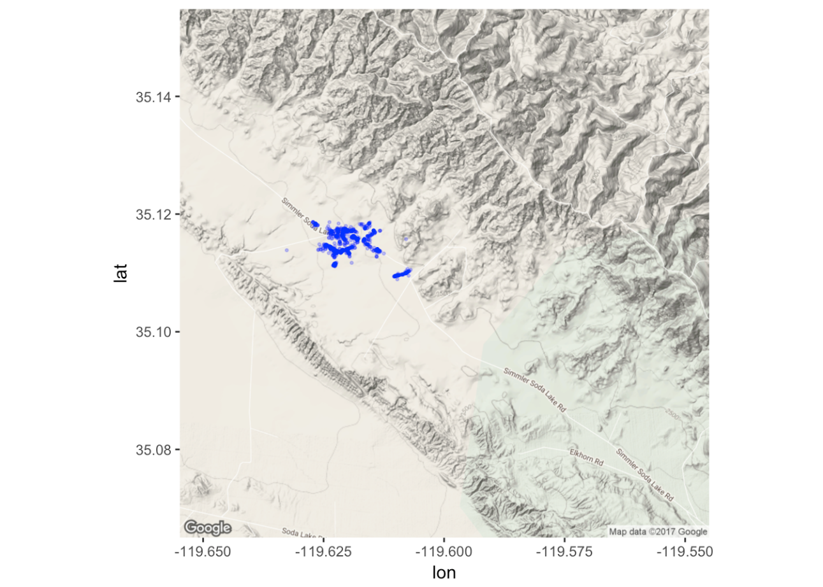

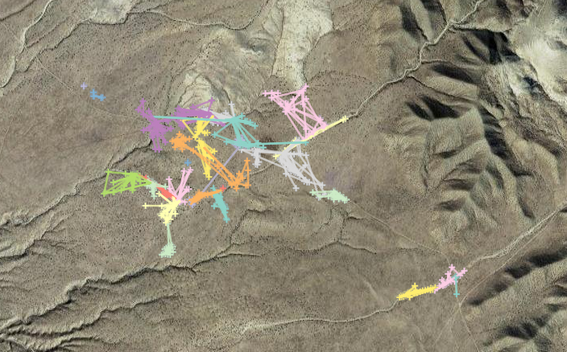

**Figure 1:** Map showing observed location and movement of all lizard observations at the study site. The first map groups all observations, the second shows individual lizards by color.

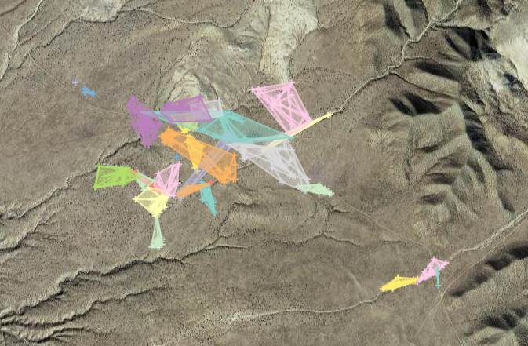

**Figure 2**: Map showing home range, calculated using a 95% minimum convex polygon estimate, for each individual. The mean home range size was 10790 m2. Different individuals are indicated by different colors.

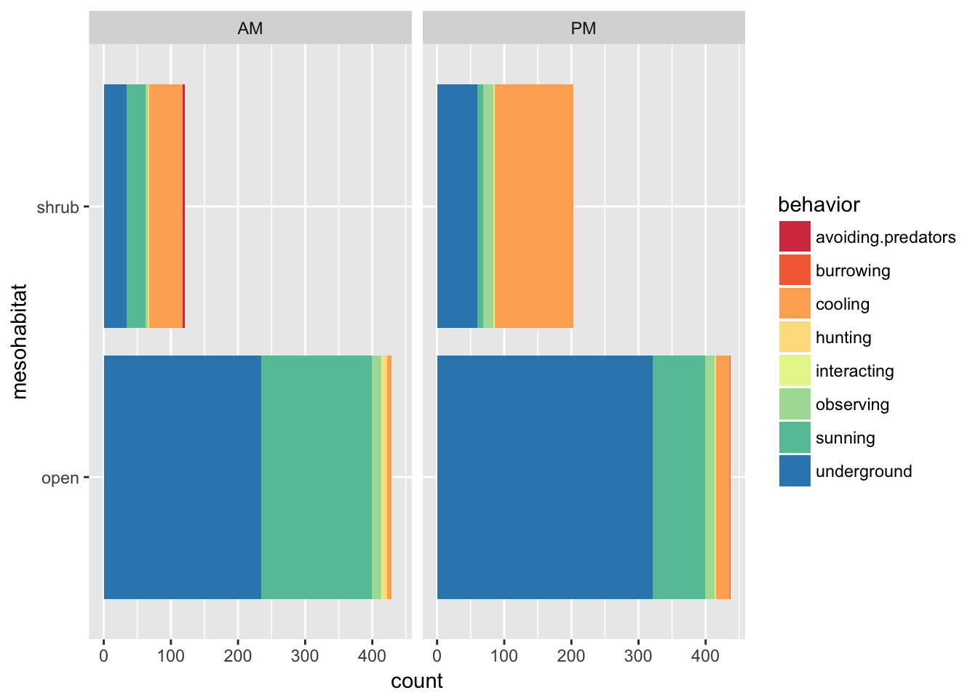

**Figure 3**: Graph showing the frequency of observation by mesohabitat type and time (AM or PM). Behavior observed is also indicated by color.

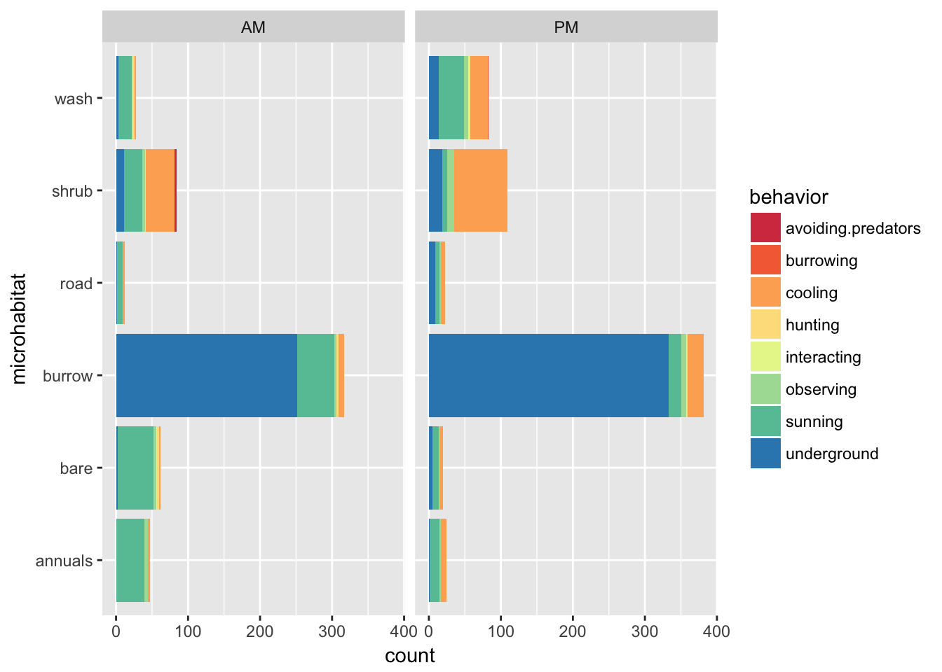

**Figure 4**: Graph showing the frequency of observation by microhabitat type and time (AM or PM). Behavior observed is also indicated by color.

**Supporting Information**

**Table S1**: Behavior classification table for lizard observations.

|  |  |
| --- | --- |
| Classification | Observed behavior |
| avoiding predators | Moving (most often running) away from predators, in this study aerial predators such as ravens and raptor species were the only predators observed. The lizard would typically look up as the predator flew overhead or nearby then move quickly towards some form of refuge, such as shrub, annuals or burrow. |
| burrowing | Actively digging a burrow, or burying itself. This behavior occurred more often towards the end of the season where some lizards were found in shallow spiral burrows after becoming dormant. This classification was only used if the lizards was actively creating its own burrow, it was not used if a pre-existing burrow was utilized. |
| cooling | Lizard moving into, or remaining still in shade. Shade could be from any source including shrubs, rocks, burrow mounds, annuals or manmade objects such as fence posts. Lizard would typically sit upright in shade with front legs extended and rear toes pointed up and off the ground. Occasionally the tail would be lifted off the ground as well. |
| hunting | Actively stalking or attempting to catch prey. Usually comprised of a slow stalking of an insect and then a sudden burst of speed for the ambush. |
| interacting | Interacting with another lizard including both members of the same species and members of other lizard species such as whiptail lizards. Usually as part of mating or territory displays. Included pushups, mating, and chasing another lizard. |
| observing | Actively observing environment. Usually from vantage point such as burrow mound, open area or from branches of shrub. Occasional head turning. |
| underground | Lizard underground, behavior could not be otherwise be determined. |
| sunning | Lizard in sun, not moving. Most often either low to ground, with lower body touching ground or sitting upright with head and shoulders up and rear toes pointed out. Eyes often closed or squinted. |

**Table S2**: Least means squares post hoc test for microhabitat:time class.

|  |  |  |  |  |  |
| --- | --- | --- | --- | --- | --- |
| contrast | estimate | SE | df | z.ratio | p.value |
| annuals,AM-bare,AM | 0.31079988 | 0.193404 | NA | 1.607 | 0.907 |
| annuals,AM-burrow,AM | -1.72643262 | 0.156305 | NA | -11.045 | <.0001 |
| annuals,AM-road,AM | 1.1420974 | 0.323435 | NA | 3.531 | 0.0212 |
| annuals,AM-shrub,AM | -0.39834764 | 0.182157 | NA | -2.187 | 0.5593 |
| annuals,AM-wash,AM | 0.85441533 | 0.238728 | NA | 3.579 | 0.0179 |
| annuals,AM-annuals,PM | 0.67209377 | 0.250885 | NA | 2.679 | 0.2367 |
| annuals,AM-bare,PM | 1.03673688 | 0.266977 | NA | 3.883 | 0.0058 |
| annuals,AM-burrow,PM | -1.50748634 | 0.154578 | NA | -9.752 | <.0001 |
| annuals,AM-road,PM | 0.5359616 | 0.258324 | NA | 2.075 | 0.641 |
| annuals,AM-shrub,PM | -1.06434383 | 0.174502 | NA | -6.099 | <.0001 |
| annuals,AM-wash,PM | 0.30677573 | 0.182551 | NA | 1.68 | 0.8774 |
| bare,AM-burrow,AM | -2.0372325 | 0.138864 | NA | -14.671 | <.0001 |
| bare,AM-road,AM | 0.83129752 | 0.315376 | NA | 2.636 | 0.2594 |
| bare,AM-shrub,AM | -0.70914752 | 0.167432 | NA | -4.235 | 0.0014 |
| bare,AM-wash,AM | 0.54361545 | 0.22769 | NA | 2.388 | 0.4145 |
| bare,AM-annuals,PM | 0.36129389 | 0.240407 | NA | 1.503 | 0.9403 |
| bare,AM-bare,PM | 0.725937 | 0.257155 | NA | 2.823 | 0.1702 |
| bare,AM-burrow,PM | -1.81828622 | 0.136917 | NA | -13.28 | <.0001 |
| bare,AM-road,PM | 0.22516172 | 0.24816 | NA | 0.907 | 0.9991 |
| bare,AM-shrub,PM | -1.37514371 | 0.159069 | NA | -8.645 | <.0001 |
| bare,AM-wash,PM | -0.00402415 | 0.16786 | NA | -0.024 | 1 |
| burrow,AM-road,AM | 2.86853002 | 0.294088 | NA | 9.754 | <.0001 |
| burrow,AM-shrub,AM | 1.32808498 | 0.122716 | NA | 10.822 | <.0001 |
| burrow,AM-wash,AM | 2.58084794 | 0.197152 | NA | 13.091 | <.0001 |
| burrow,AM-annuals,PM | 2.39852639 | 0.21171 | NA | 11.329 | <.0001 |
| burrow,AM-bare,PM | 2.7631695 | 0.230553 | NA | 11.985 | <.0001 |
| burrow,AM-burrow,PM | 0.21894627 | 0.075975 | NA | 2.882 | 0.1473 |
| burrow,AM-road,PM | 2.26239421 | 0.220475 | NA | 10.261 | <.0001 |
| burrow,AM-shrub,PM | 0.66208878 | 0.111036 | NA | 5.963 | <.0001 |
| burrow,AM-wash,PM | 2.03320835 | 0.1233 | NA | 16.49 | <.0001 |
| road,AM-shrub,AM | -1.54044504 | 0.308607 | NA | -4.992 | <.0001 |
| road,AM-wash,AM | -0.28768207 | 0.345033 | NA | -0.834 | 0.9996 |
| road,AM-annuals,PM | -0.47000363 | 0.353553 | NA | -1.329 | 0.9754 |
| road,AM-bare,PM | -0.10536052 | 0.365148 | NA | -0.289 | 1 |
| road,AM-burrow,PM | -2.64958374 | 0.293174 | NA | -9.038 | <.0001 |
| road,AM-road,PM | -0.6061358 | 0.35887 | NA | -1.689 | 0.8737 |
| road,AM-shrub,PM | -2.20644123 | 0.304151 | NA | -7.254 | <.0001 |
| road,AM-wash,PM | -0.83532167 | 0.308839 | NA | -2.705 | 0.2236 |
| shrub,AM-wash,AM | 1.25276297 | 0.218218 | NA | 5.741 | <.0001 |
| shrub,AM-annuals,PM | 1.07044141 | 0.231455 | NA | 4.625 | 0.0002 |
| shrub,AM-bare,PM | 1.43508453 | 0.248807 | NA | 5.768 | <.0001 |
| shrub,AM-burrow,PM | -1.1091387 | 0.120509 | NA | -9.204 | <.0001 |
| shrub,AM-road,PM | 0.93430924 | 0.239498 | NA | 3.901 | 0.0054 |
| shrub,AM-shrub,PM | -0.66599619 | 0.145186 | NA | -4.587 | 0.0003 |
| shrub,AM-wash,PM | 0.70512337 | 0.154767 | NA | 4.556 | 0.0003 |
| wash,AM-annuals,PM | -0.18232156 | 0.278174 | NA | -0.655 | 1 |
| wash,AM-bare,PM | 0.18232156 | 0.29277 | NA | 0.623 | 1 |
| wash,AM-burrow,PM | -2.36190167 | 0.195786 | NA | -12.064 | <.0001 |
| wash,AM-road,PM | -0.31845373 | 0.284901 | NA | -1.118 | 0.994 |
| wash,AM-shrub,PM | -1.91875916 | 0.211869 | NA | -9.056 | <.0001 |
| wash,AM-wash,PM | -0.5476396 | 0.218546 | NA | -2.506 | 0.336 |
| annuals,PM-bare,PM | 0.36464311 | 0.302765 | NA | 1.204 | 0.9888 |
| annuals,PM-burrow,PM | -2.17958011 | 0.210439 | NA | -10.357 | <.0001 |
| annuals,PM-road,PM | -0.13613217 | 0.295163 | NA | -0.461 | 1 |
| annuals,PM-shrub,PM | -1.7364376 | 0.225479 | NA | -7.701 | <.0001 |
| annuals,PM-wash,PM | -0.36531804 | 0.231765 | NA | -1.576 | 0.9179 |
| bare,PM-burrow,PM | -2.54422323 | 0.229385 | NA | -11.091 | <.0001 |
| bare,PM-road,PM | -0.50077529 | 0.308957 | NA | -1.621 | 0.9018 |
| bare,PM-shrub,PM | -2.10108072 | 0.243258 | NA | -8.637 | <.0001 |
| bare,PM-wash,PM | -0.72996115 | 0.249095 | NA | -2.93 | 0.1301 |
| burrow,PM-road,PM | 2.04344794 | 0.219254 | NA | 9.32 | <.0001 |
| burrow,PM-shrub,PM | 0.44314251 | 0.108591 | NA | 4.081 | 0.0026 |
| burrow,PM-wash,PM | 1.81426207 | 0.121103 | NA | 14.981 | <.0001 |
| road,PM-shrub,PM | -1.60030543 | 0.233728 | NA | -6.847 | <.0001 |
| road,PM-wash,PM | -0.22918587 | 0.239797 | NA | -0.956 | 0.9985 |
| shrub,PM-wash,PM | 1.37111956 | 0.145679 | NA | 9.412 | <.0001 |